# Convenient

# Secure

Facial Recongition

1 out of 3 Americans have experienced a package theft. Roughly 325,000 houses were broken into in 2019.

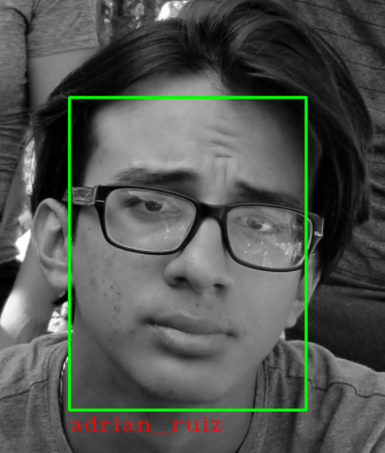

KED uses facial recognition to unlock the door. It uses machine learning to identify a person’s a face, and it recognizes the user. With a built security system, it can alert the user if a break in occurs. Couriers could be allowed drop off packages inside the user’s home to avoid theft.